DASHBOARD DESIGN
Field | Details
Date | 20-Aug-2026TO22-Aug-2026
Team ID | Individual
Project Name | India’s Agricultural Crop Production Analysis (1997–2021
Maximum Marks | 5 Marks

Activity 1: Interactive and Visually Appealing Dashboard
The India’s Agricultural Crop Production Analysis (1997–2021) Tableau dashboard is designed to provide a clear and interactive view of agricultural crop production across different states, crops, years, and production categories.
Dashboard Design Principle | Implementation in My Tableau Dashboard
Clear and Intuitive Layout | Dashboard components are arranged in a structured layout with KPIs and visualizations positioned for easy understanding.
Use Appropriate Visualizations | Bar charts, line charts, maps, KPI cards, and comparison charts are used according to the type of agricultural analysis required.
Colour and Theming | A consistent colour theme is used to differentiate crops, states, and production categories and make important values easy to identify
Interactive Filters and Slicers | Filters allow users to explore agricultural production based on relevant dimensions such as state, crop, year, and crop category.
Drill-Down Capabilities | Users can explore detailed information from broader state-level analysis to specific crop-level production where applicable.
Responsive Design | Dashboard elements are organized to maintain readability and usability across different screen sizes.
Custom Visuals and Icons | KPI cards and visual elements are used to make important agricultural production indicators more noticeable.
Use of Infographic | Charts and graphical elements present complex agricultural production information in a simple and understandable form.

Major Outcomes from the Dashboard
- Overall Crop Production: The dashboard provides an overview of agricultural crop production in India through KPI cards and visualizations.
- State-wise Comparison: The dashboard helps identify states with relatively higher and lower crop production.
- Crop-wise Production: The dashboard compares production across different crops and highlights major agricultural crops.
- Year-wise Trends: The dashboard shows how crop production changes over the years from 1997 to 2021.
- State and Crop Analysis: State-wise and crop-wise analysis helps identify regions and crops with higher and lower production.
- Production Distribution: Visualizations show the distribution of agricultural production across different states and crop categories.
- Top Crops: The dashboard identifies crops with the highest production levels.
- Year-wise Analysis: The dashboard helps analyze changes and trends in agricultural production over the selected period.
- Interactive Analysis: Tableau filters and interactive features allow users to explore the data according to their requirements.
- Decision Support: The dashboard converts raw agricultural data into visual insights that can support agricultural planning and production-related decisions.

DASHBOARD NO 1:
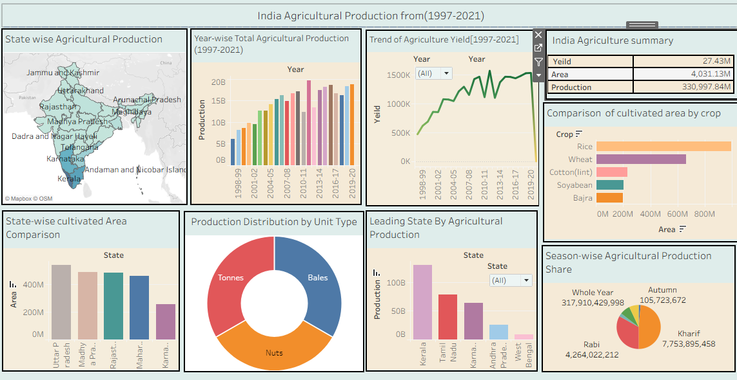

Activity 2: Publish Dashboard on Tableau Public
Tableau Public Dashboard Link:
https://public.tableau.com/views/Book2_17877409344640/Dashboard1?:language=en-US&publish=yes&:sid=&:redirect=auth&:display_count=n&:origin=viz_share_link
Note: You need to publish your .twbx workbook to Tableau Public first and then paste the generated public URL in your project document.

